**Eccentric millionaire lives in a bunker beneath a Cold War radar- and he's going to find UFOs**

Some millionaires might be happy frittering away their hard–earned cash on speed boats, golfing holidays, and perhaps the odd football team or two.

But William Sachiti is far from your run–of–the–mill businessman.

Much more Blofeld than [Bill Gates](https://www.dailymail.co.uk/news/bill-gates/index.html), Mr Sachiti has decided to use his millions in a far less conventional way.

Naturally, that meant buying a Cold War [RAF](https://www.dailymail.co.uk/news/raf-the-royal-air-force/index.html) base and [firing up the radar station to hunt for](https://www.dailymail.co.uk/sciencetech/article-10985157/Hunt-UFOs-Millionaire-asks-public-newly-purchased-Cold-War-era-radar-system.html) [UFOs](https://www.dailymail.co.uk/news/ufos/index.html)[.](https://www.dailymail.co.uk/sciencetech/article-10985157/Hunt-UFOs-Millionaire-asks-public-newly-purchased-Cold-War-era-radar-system.html)

From his 'supervillain lair' in the nuclear bunker beneath former RAF Neatishead, Norfolk, Mr Sachiti is building what may be the world's most sophisticated UFO–hunting machine.

But don't let the secluded compound, legions of [robots](https://www.dailymail.co.uk/sciencetech/robots/index.html), and enormous leather swivel chair fool you – Mr Sachiti isn't taking his role as Norfolk's latest supervillain too seriously.

'I'm a bit of a hedonist,' Mr Sachiti told Daily Mail from the freezing cold control room beneath the radar station.

'There's no point being the richest man in the graveyard, I just want to have fun and let people track UFOs.'

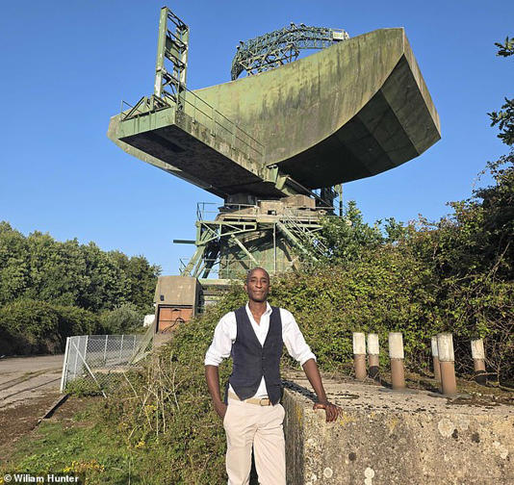

William Sachiti (pictured) is a millionaire inventor, entrepreneur, and AI expert who purchased a former RAF radar station. He says he's going to use it to hunt for UFOs

Mr Sachiti, 41, is a British Zimbabwe–born inventor and entrepreneur best known for making autonomous delivery vehicles for the RAF, robots for the NHS, and for a particularly unsuccessful appearance on Dragon's Den.

In 2017, Mr Sachiti founded The Academy of Robotics with the goal of developing autonomous vehicles, robots, and AI systems.

His crowning achievement was the creation of Kar–go, a company which, in 2019, made the UK's first roadworthy autonomous car.

It was this goal, rather than the hunt for extraterrestrials, which actually led Mr Sachiti to make the unusual business decision to purchase a disused RAF radar station.

During the height of Cold War paranoia, RAF Neatishead was a key part of the UK's air defence network, keeping a watchful eye out for a potential nuclear attack.

However, by the 1990s, the main radar had been decommissioned, and in 2004, the decision was made to significantly scale back activity at the base.

For almost two decades, the site lay unused as the hulking green mass of the radar slowly turned brown with rust.

But with private roads safely away from the public and buildings ready to become workshops, the base was the perfect place for Mr Sachiti to test his robots.

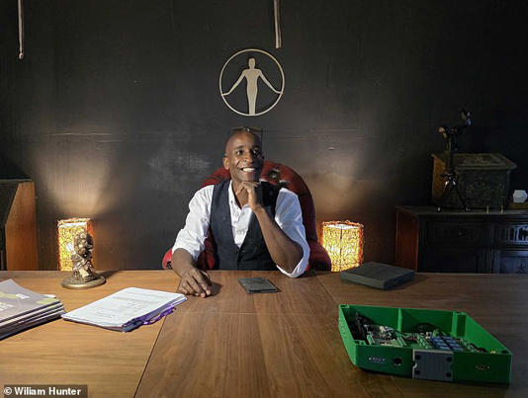

From his 'supervillain lair' in a nuclear bunker beneath the former RAF Neatishead, Mr Sachiti claims to have created a 'UFO hunting machine'

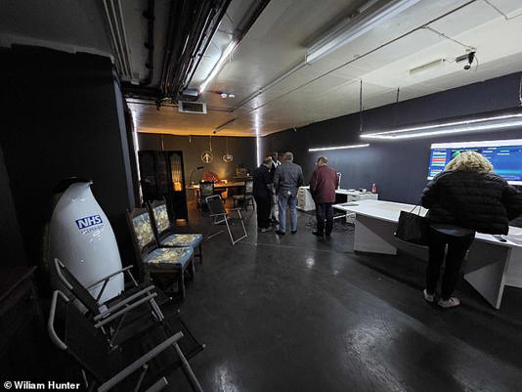

MailOnline visited Mr Sachiti, alongside a group of retired RAF radar operators and Mr Sachiti's  investors, to get a first look at his novel radar system for hunting UFOs

**Who is William Sachiti?**

William Sachiti is the millionaire owner of the Academy of Robotics, a company dedicated to creating autonomous robots.

Mr Sachiti was born in 1984 in Harare, Zimbabwe and came to the UK when he was 17.

He appeared on Dragon's Den in 2009 with his company 'Clever Bins', but was rejected by all four dragons.

In 2011, he founded the digital concierge service mycityventure, which was sold to SecretEscapes in 2014.

His most successful venture is the autonomous car company Kar–go, which created the UK's first roadworthy self–driving car.

Mr Sachiti purchased the site in early 2022 and converted it into the headquarters of The Academy of Robotics, where he now lives and works.

When The Daily Mail came to visit Mr Sachiti at his home on the former base, the site seemed caught somewhere between a graveyard for ageing military equipment and the playground of an eccentric millionaire.

A herd of Scottish deer happily graze amid the remains of concrete pillboxes, and the ground is littered with craters made, not by explosions, but by Mr Sachiti himself to form ponds for the flamingos he plans to introduce.

'When I moved in, I thought it was going to look like Tron, but it's starting to look a lot more like Westworld,' Mr Sachiti said as he gave a tour of the grounds.

However, the property's most obvious feature is the enormous Type–84 radar that looms over Mr Sachiti's bungalow.

This radar was once responsible for tracking and identifying every aircraft moving over the south of the UK, but it hasn't been used in over two decades.

Mr Sachiti's conspicuously villainous office is located deep beneath this structure, down a pitch–black corridor lined with enough concrete and steel to withstand a nuclear blast.

Although Mr Sachiti freely admits he doesn't 'know anything' about how radars work, what he does know about is making artificial intelligence.

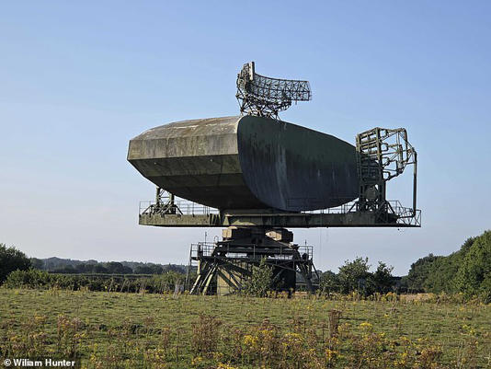

During the Cold War, the Type-84 radar at RAF Neatishead was a key part of the UK's nuclear defence system and was responsible for detecting every plane flying over the south of the UK

He says: 'I have all the documents of how the Type–84 was made and how all the tech works, so what if I fed all this into a super–intelligent AI and turn it into the world's best radar expert? And that's how I made RadarBot.'

RadarBot is just one of the many AI assistants who keep Mr Sachiti company in his somewhat solitary existence at the base.

As he talks, Mr Sachiti frequently pulls up various AI assistants to explain various topics and, in one instance, couldn't find the light switch since 'the AI normally does that'.

At first, I couldn't see why Mr Sachiti, who has a wife and children and seemed extremely sociable, chose to live on the base by himself.

However, it soon became clear that everything was not quite right at RAF Neatishead.

As we walked around the grounds, we came across one of Mr Sachiti's beloved deer decomposing under a cloth.

Just a month ago, Mr Sachiti explained, someone had broken into the compound and killed a number of deer, leaving their bodies on the ground.

In another incident, just weeks before our visit, a workshop holding Mr Sachiti's self–driving car was broken into and vandalised.

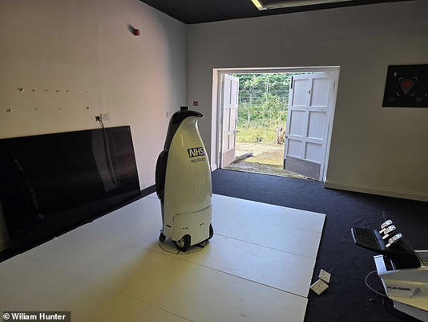

While converting the base into a location for testing autonomous robots, Mr Sachiti realised that he might be able to get the Type-84's smaller 'secondary surveillance radar' (SSR) working



Mr Sachiti says that converting the UK's Cold War air defence system into a UFO-hunting tool was his equivalent of fixing up a car over the summer

'I get horrible messages, constant abuse, they shot my animals, and no one takes it seriously,' said Mr Sachiti.

'It does affect me, I don't have my staff here, I can't have my kids here. There's guns being shot on my property, how could I have my kids in the garden?

'I don't have investor days anymore because you never know who's coming or whether they're going to vandalise the place. I wish people would just call it out more when they see people being horrible online for no reason.'

In that isolation, however, what Mr Sachiti does have is a nearly endless amount of time and energy to work on new creations and build his AIs.

In fact, part of the reason he invited Daily Mail to the base along with a group of his investors and former RAF radar operators was to prove that this system really worked and that he hadn't just 'been spending too much time in the bunker'.

'There's no such thing as done when you're surrounded by a cluster of super–intelligent AIs and you're tinkering until three or four in the morning,' he said.

It was in the depths of such an AI–powered late–night tinkering session that Mr Sachiti's UFO–hunting side–hustle began.

Buying the base purchase had come with a catch: to get planning permission, he was required to conduct restoration and renovation on the listed buildings – including the Type–84 radar station.

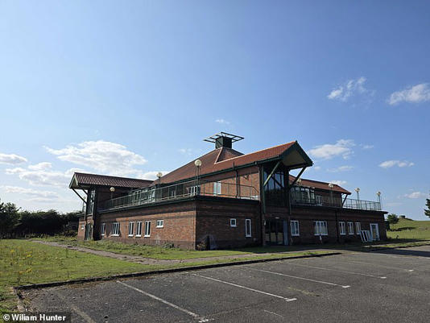

Mr Sachiti was required to maintain and conserve the former military buildings, such as the officers' mess (pictured) and the radar station, which is where the idea to restart the Type-84 radar began

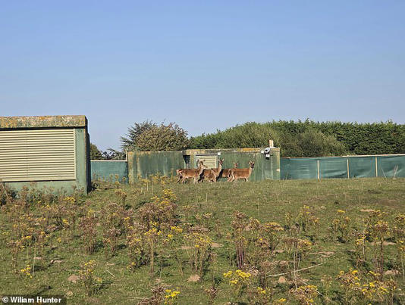

Mr Sachiti has introduced a herd of Scottish deer onto the base, which now roam amongst the former military buildings

With RadarBot's assistance, Mr Sachiti soon had the Type–84's radar receiver up and running, but was stumped as to what he should actually do with it.

That's when Mr Sachiti decided to post on Reddit to see what the internet thought.

Whether it was a joke or not, the reply soon came back decisively: Mr Sachiti should hunt for UFOs.

'I think what happens when you work in tech for so long is that certain things become intuitive and just look like they should be possible,' said he said.

'Then when people say it's not possible, it just became a bit of a challenge.'

Although it might sound bizarre, Mr Sachiti seems to have seen the prospect of turning the UK's Cold War defences into a UFO–hunting network as a nice way to wind down after work.

'Some people have that car they refurbish over the summer, this is my version of that summer car,' said Mr Sachiti.

'I thought, why not? Either it slowly dies or you do something crazy and a lot of people benefit from it'.'

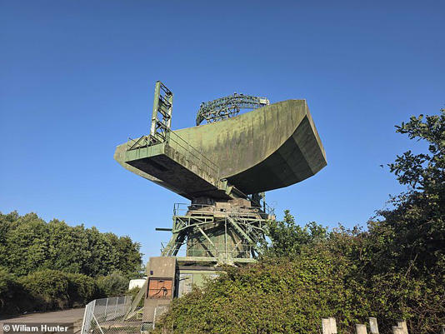

Although the Type-84's radar illuminator is unusable, Mr Sachiti has found a way to use the radio signals emitted by passing planes to detect anything moving in the sky

But, as seems to be the case with many of Mr Sachiti's pet projects, his experiments with AI and radar systems were soon going well beyond a simple hobby.

Since he couldn't use the Type–84's radar illuminator, it being far too power hungry for civilian use, he was limited to the smaller, passive secondary surveillance radar (SSR).

So, instead of using the radar itself as the illuminator, Mr Sachiti's solution was to build a computer program that could listen for the signals which are already out there.

'What I thought is that, instead of using something like a BBC broadcast for reflection, I could use a plane in the sky,' Mr Sachiti said.

'I know where its signal is at all times, so what if I use that plane as an illuminator? And the plane next to it, and the one next to that, or all the planes in the sky.'

That gives you a near–perfect picture of everything that is moving in the sky in a 150 to 250–mile radius, to a tested accuracy of 250 metres.

Using the rather ominously labelled 'Global Domination Mode' to use the signals from every plane in the sky, Mr Sachiti's radar should pick up every large drone flying above London over 100 miles away.

What makes this so bold is that anyone with Mr Sachiti's software can either log in and use RAF Neatishead's SSR or grab a £20 Amazon antenna and scan their own 150–mile radius.

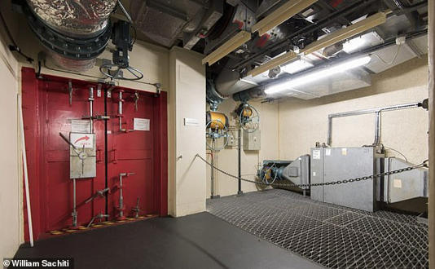

Meet the eccentric millionaire hunting for UFO's with a Cold War radar

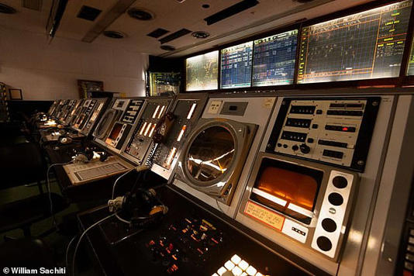

This radar station was once able to track every aircraft over the south of the UK and police the airspace on behalf of NATO, now anyone can use its capabilities with a piece of software Mr Sachiti has released for free

In theory, the resulting network would be unjammable, undetectable, unspoofable, and almost impossible to trick with existing stealth technologies.

With just 20–30 of these antennas placed strategically around the country, nothing would move in the skies above Britain without Mr Sachiti and his network of UFO hunters seeing it.

If you want to hunt for UFOs yourself, you can now [download this software for free from Mr Sachiti's website](https://academyofrobotics.co.uk/secretradar/) to build your own station or search using RAF Neastishead's Type–84.

Mr Sachiti says: 'We essentially ended up in the world's biggest UFO database just for fun.'

Asked whether he has considered that the software might have military applications, particularly the possible drone hunting capabilities, Mr Sachiti seemed unconcerned.

'I'm a bit of a happy hippy person, for me it's fun and I don't really ever want to make weapons of war,' says Mr Sachiti.

'This is legitimately a UFO hunting machine, but it could be used for other things which I don't have an interest in.'

However, Mr Sachiti's decision to create a 'UFO hunting machine' might have been inspired by something more than a desire to have a bit of fun.

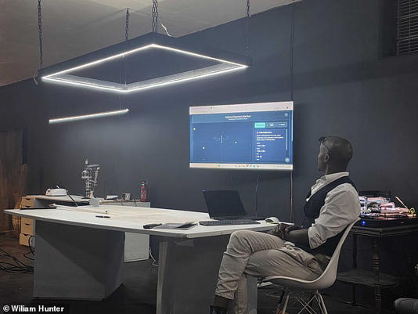

Anyone using Mr Sachiti's UFO-finding software will be able to either use the radar capabilities at RAF Neatishead or create their own radar station using a cheap, easily available antenna

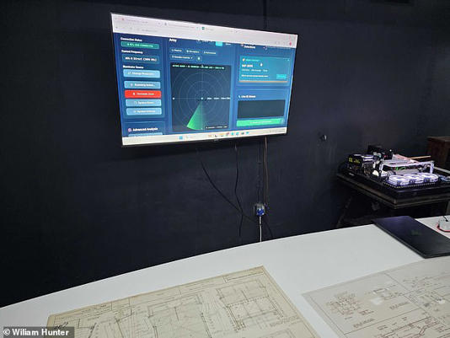

Mr Sachiti says he plans to release the software for free to the UFO community and that, if there are any UFOs moving over the UK, this will find them

He said: 'I remember being in Zimbabwe in Africa, watching Star Trek thinking, 'wow!', so my passion for tech came from literal Star Trek.'

But it was also during his childhood in Zimbabwe that Mr Sachiti found himself close to one of the most well–documented UFO sightings in history.

In 1994, over 60 children at the Ariel school in Ruwa, Zimbabwe, reported seeing a UFO landing in the school grounds.

Many reported having encountered a 'being' and were plagued by a terror that would follow many for their entire lives.

Mr Sachiti recalls: 'I was in primary school, at a school named Greatstone Park, and we had just had a hockey game with students from the Aerial school.

'Apparently, the school had just seen a UFO land, and it was the talk of all the schools everywhere.

'So in my youth, we were all drawing pictures of UFOs and aliens and things, and I think maybe that dropped a seed, and that's where it started.

Personally, Mr Sachiti says that UFOs' '100 per cent exist' but that he isn't convinced that they are extraterrestrial in origin.

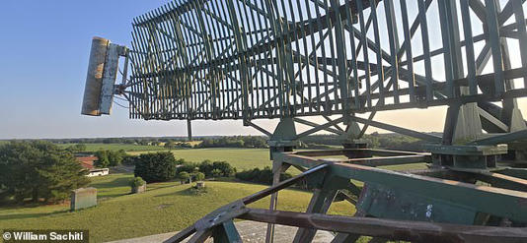

Mr Sachiti says he is convinced UFOs exist, but doesn't feel the need to spend time looking for them himself. He told Daily Mail: 'A person who makes a shovel isn't going to go digging for gold'. Pictured: The view from the top of the Type-84 radar

He says: 'The next model going down from humans is a chimp, right? But although there's only a 0.3 per cent genetic difference, the smartest chimp on Earth doesn't even know we're here.

'It doesn't know about electricity, the Hubble Space Telescope, all this tech. So if there's a being that's as much smarter than us as we are smarter than chimps, we wouldn't even know it was there.

'Nature didn't evolve from snails, go up to chimps, then to humans and stop there. Nature went past that ages ago, we just can't see it.'

However, despite his absolute conviction in their existence and having spent months building a system to find them, Mr Sachiti says he's not bothered about looking for UFOs himself.

He said: 'A person who makes a shovel isn't going to go digging for gold.

'I've made the tool and it's my job to make it the best tool I can, and when they find aliens, I hope they'll tell me.'